# **Home Learning Task: R**

*Compulsory Task: Using the ggplot in-built data sets in RStudio and the qplot function, get your creative juices flowing and create a meaningful and impactful data visualization using your preferred data set.*

Below I have chosen to extract the data set about diamonds, the variables used to draw visualisations were Price and Carat. These variables would indicate an upward positive trend with price and carrot, meaning the greater the carrot size, the greater the price.

I then coloured the data points using the following function colour=clarity to show the distinctions between the diamond types as per their clarity.

The function size=cut was used to help provide a better visualisation on the sizes of the cut per diamond.

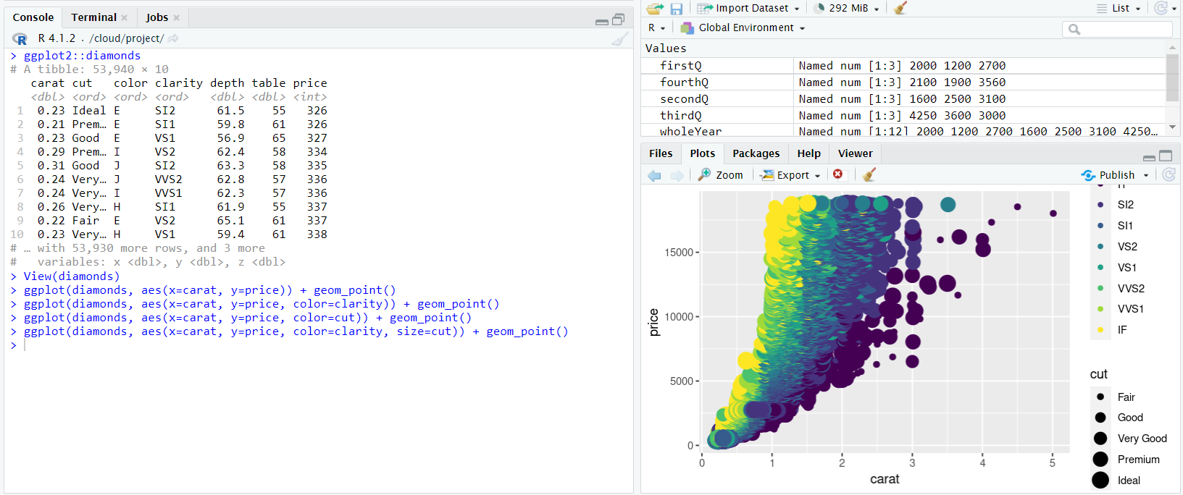All variables including, price, carat, colour, clarity and cut are used to depict a clear visualisations and interpretation of the diamond data.

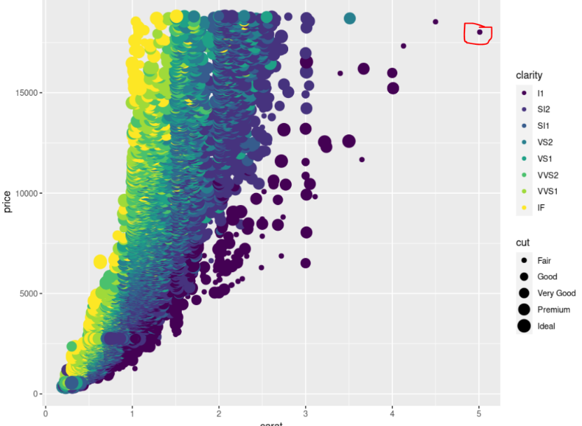

We can immediately identify from this graph that despite the positive upward trend, there is a % of diamonds that although hold the biggest carrot size, is not the most expensive, when we drill deeper, we know that this type of diamond is of L1 clarity and cut fair.